Supplementary Information — Camera-Back Physics
This Supplementary contains full mathematical derivations, simulation parameters, algorithms, and additional figures.
Supplementary Figure S1: double_band_detector_cropped.png
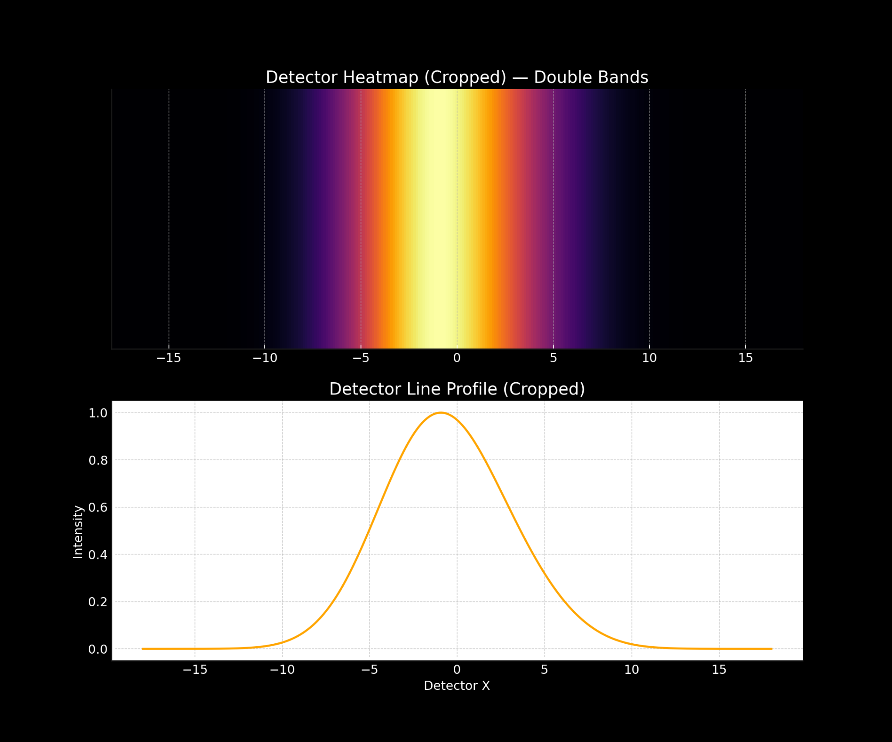

Supplementary Figure S2: double_band_detector_full.png
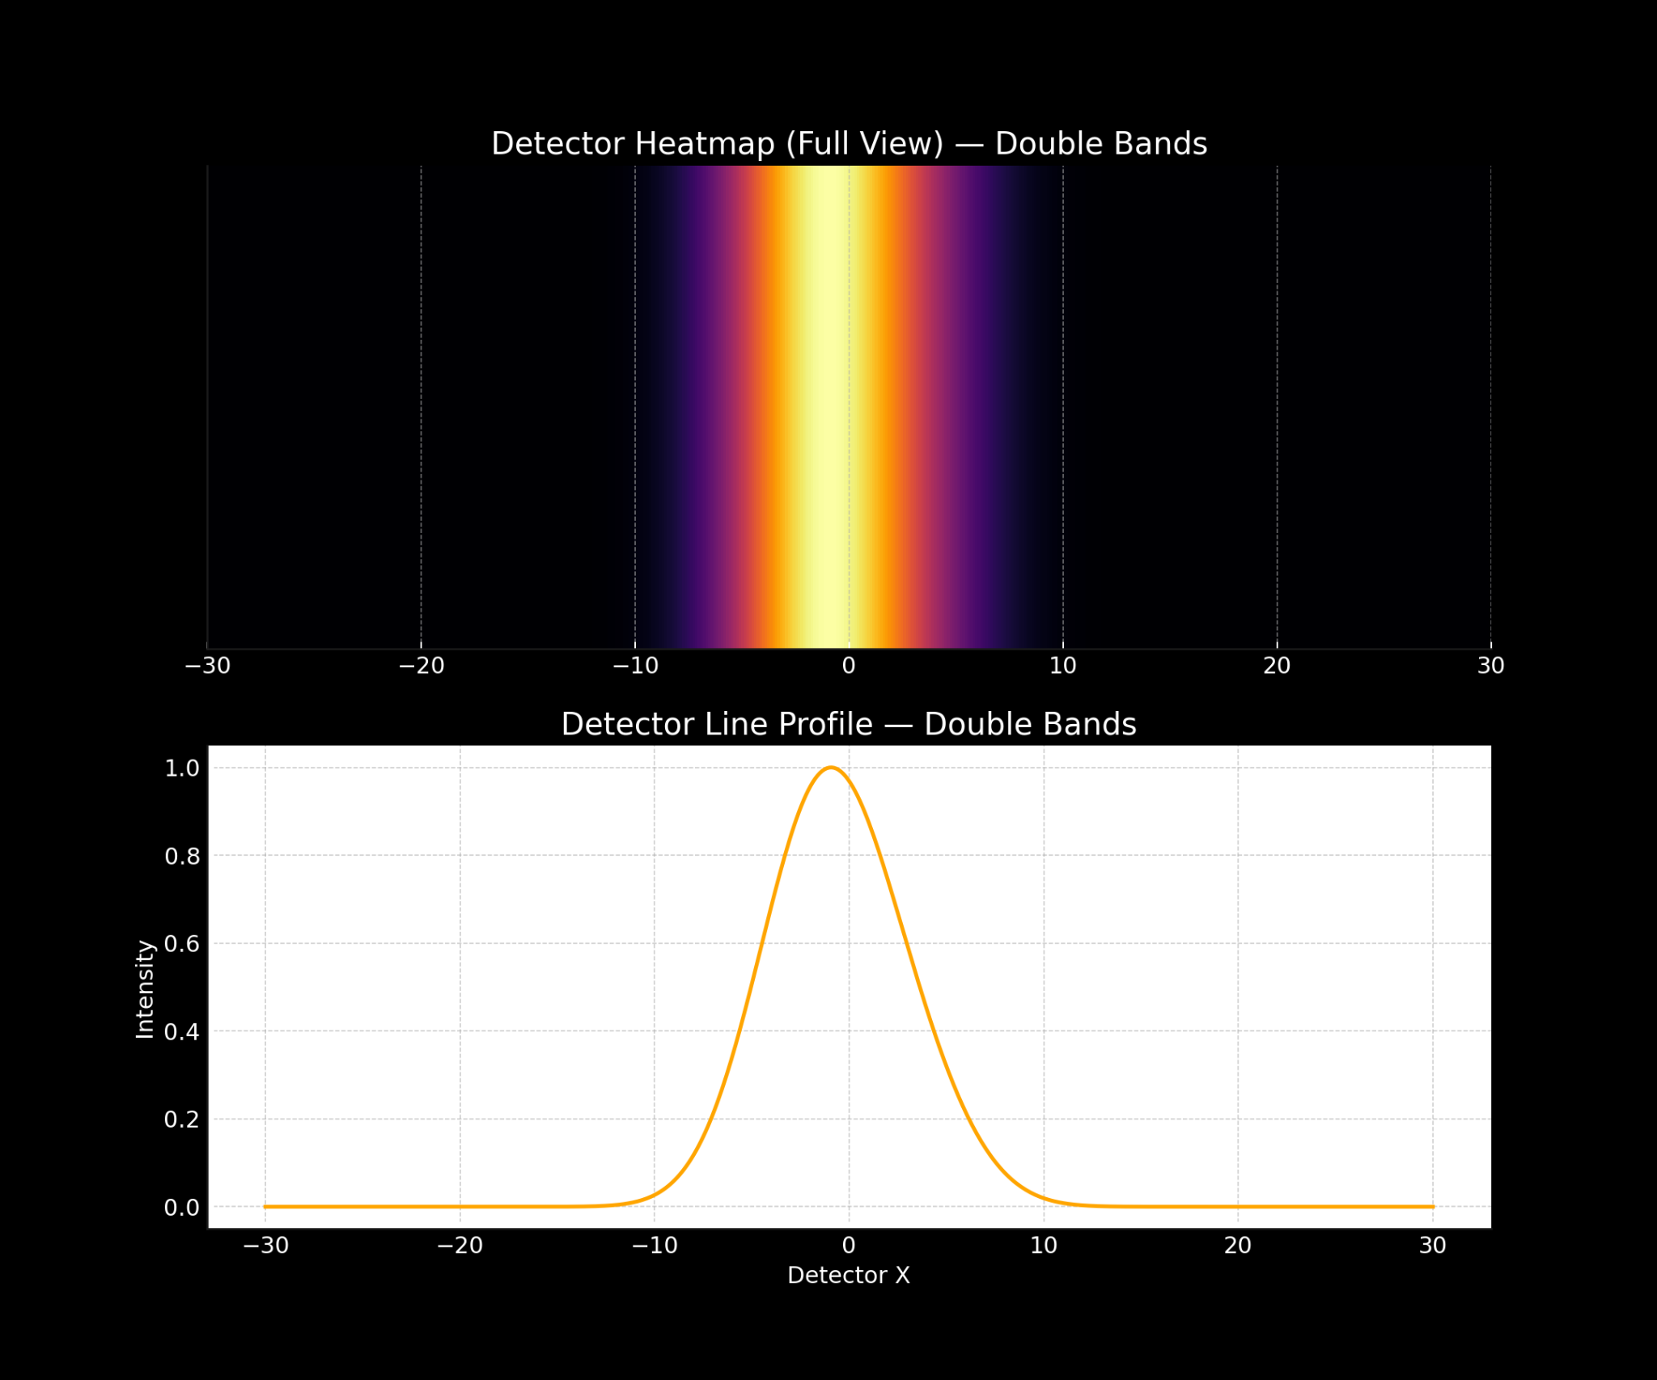

Supplementary Figure S3: double_band_fraunhofer_cropped.png
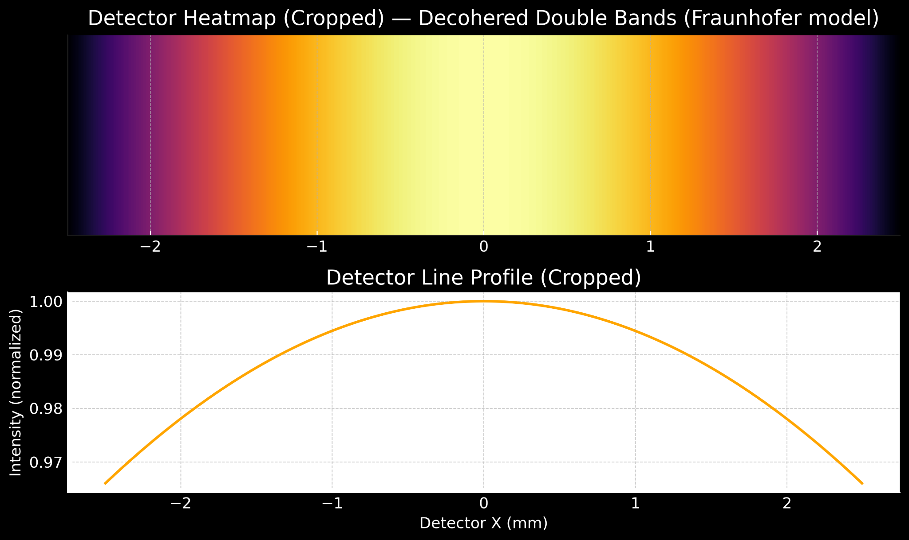

Supplementary Figure S4: double_band_fraunhofer_full.png
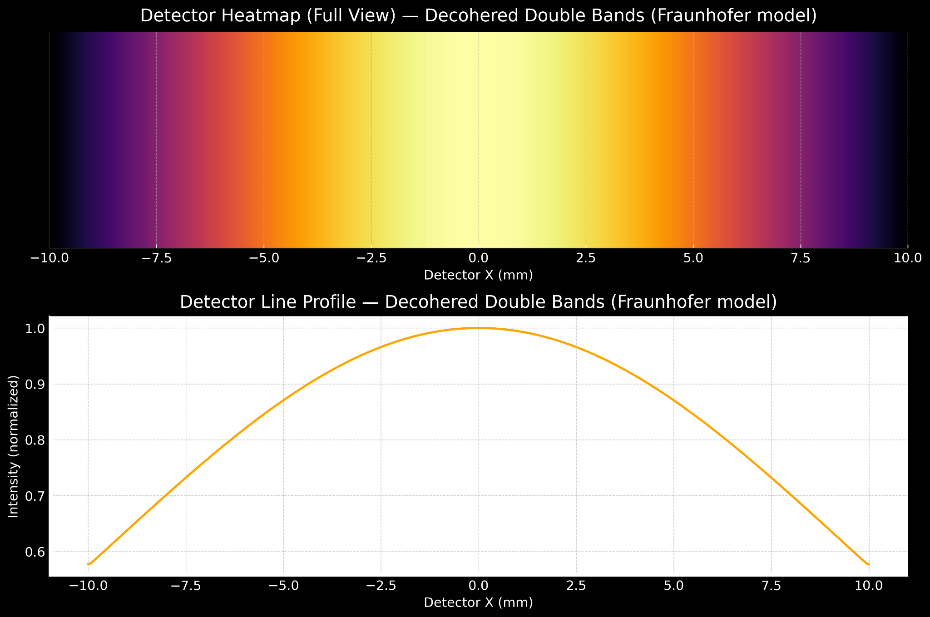

Supplementary Figure S5: double_band_fraunhofer_separated_cropped.png
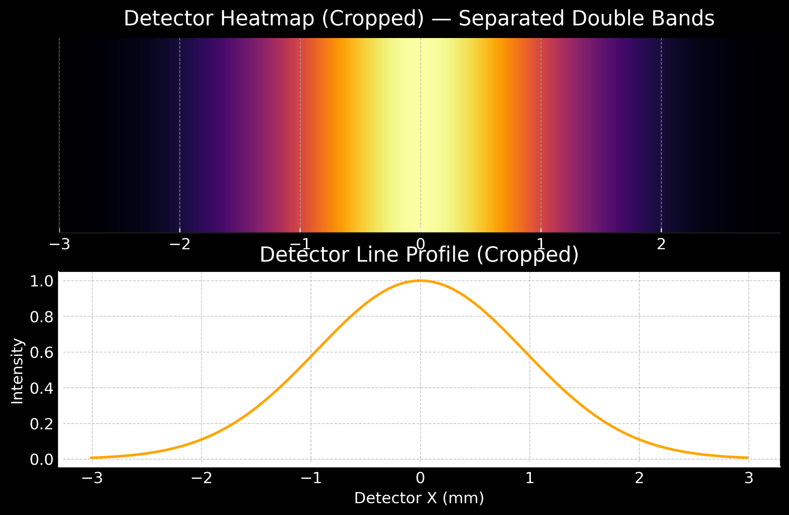

Supplementary Figure S6: double_band_fraunhofer_separated_full.png
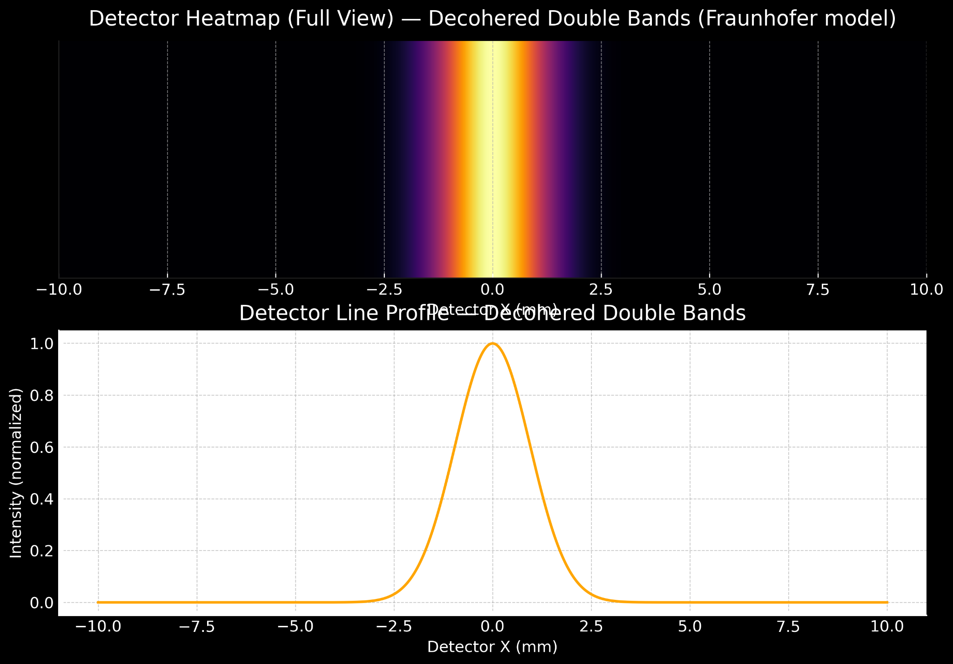

Supplementary Figure S7: double_band_imaged_cropped.png
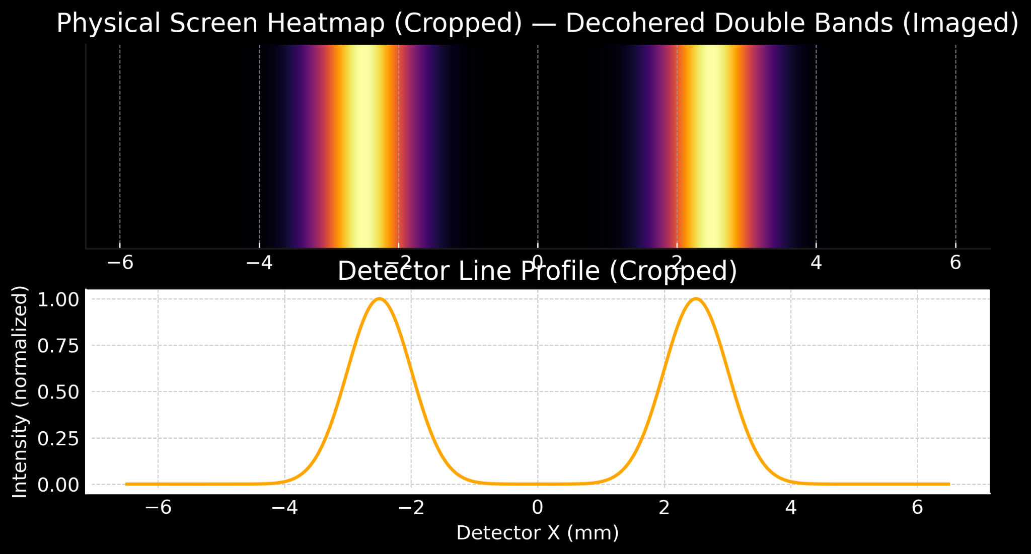

Supplementary Figure S8: double_band_imaged_full.png
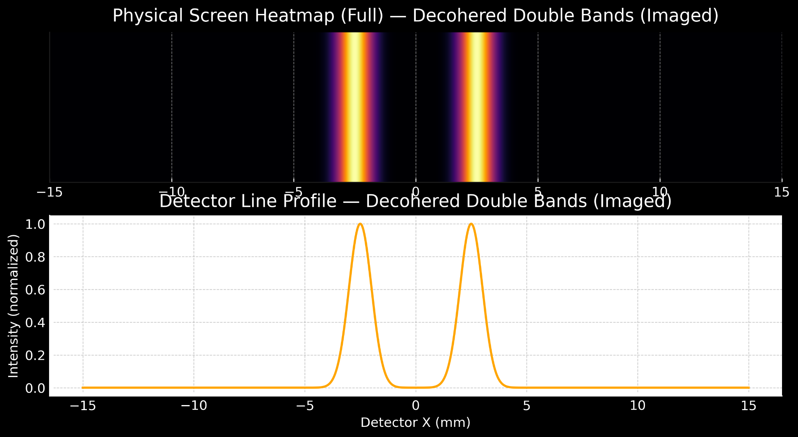

Supplementary Figure S9: double_band_wide_cropped.png
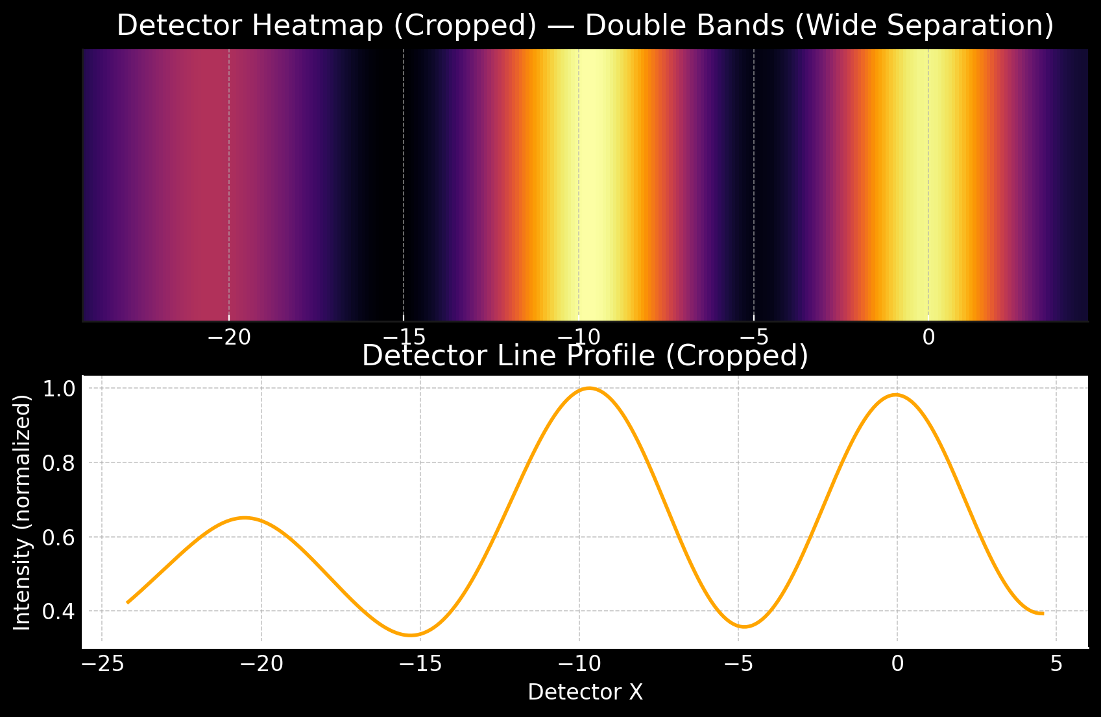

Supplementary Figure S10: double_band_wide_full.png
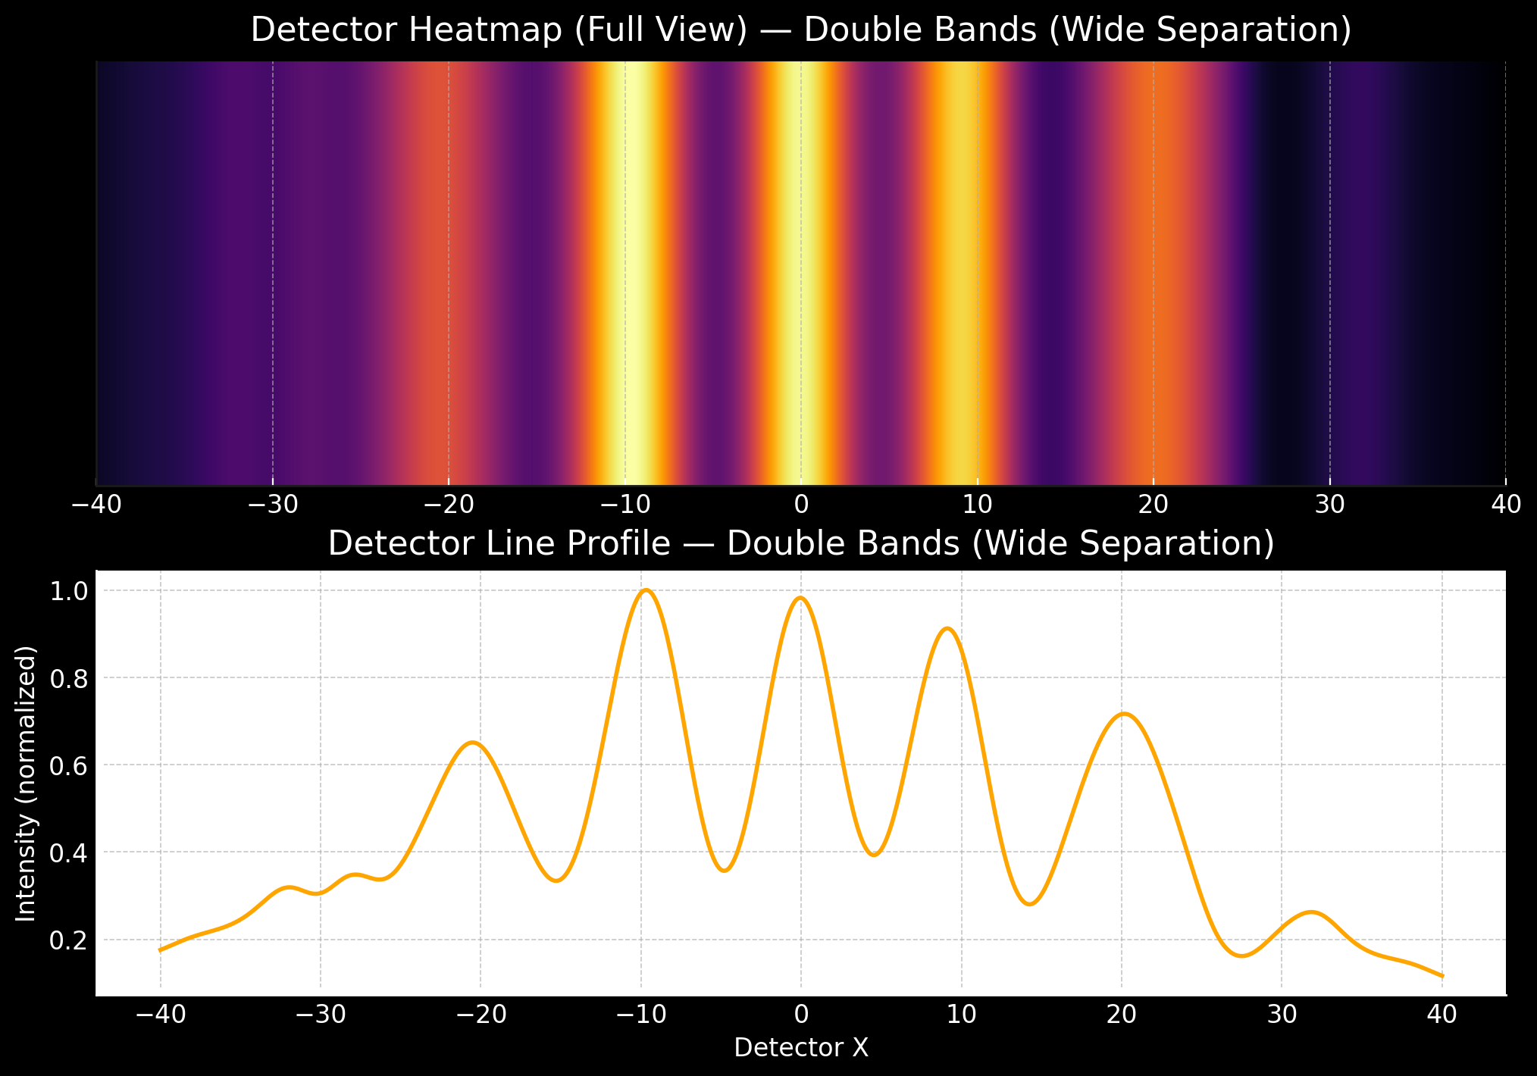

Supplementary Figure S11: imprint_camera_view.gif (first frame)


Supplementary Figure S12: imprint_camera_view (1).gif (first frame)
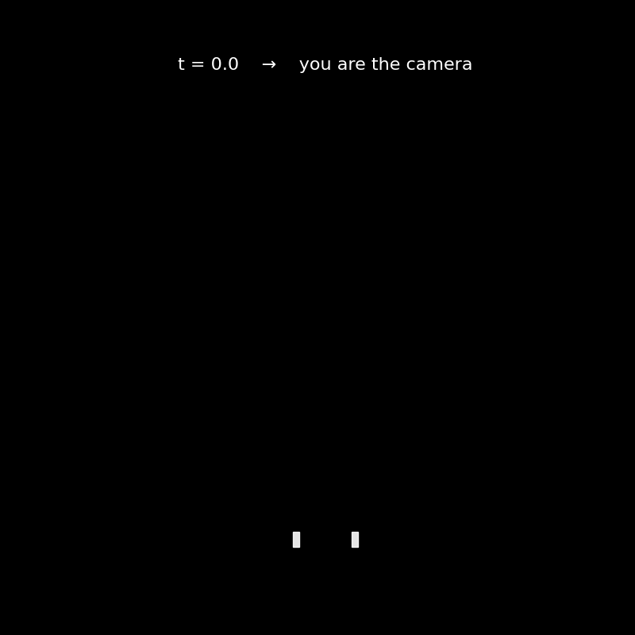

Supplementary Figure S13: Snapshot from imprint_camera_view (1).mp4
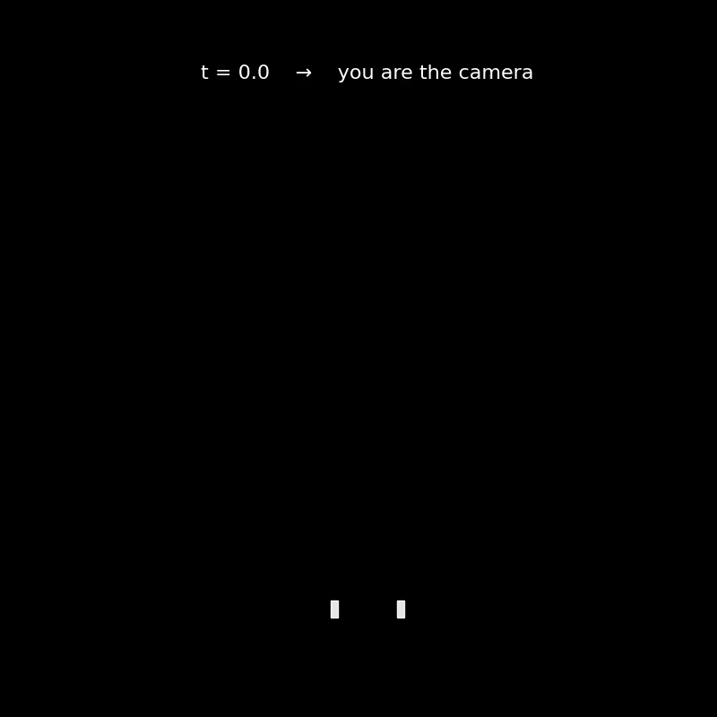

Supplementary Figure S14: Snapshot from imprint_camera_view.mp4


Supplementary Figure S15: Snapshot from imprint_preview_tiny.mp4
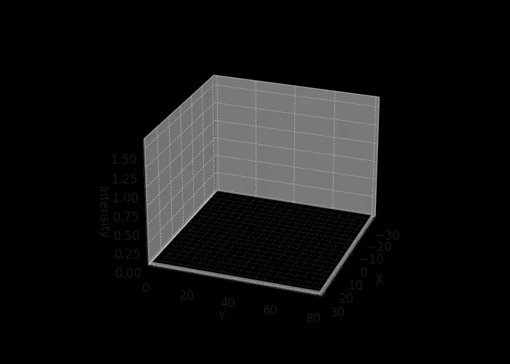

Supplementary Figure S16: Snapshot from imprint_detector_transition_tiny.mp4
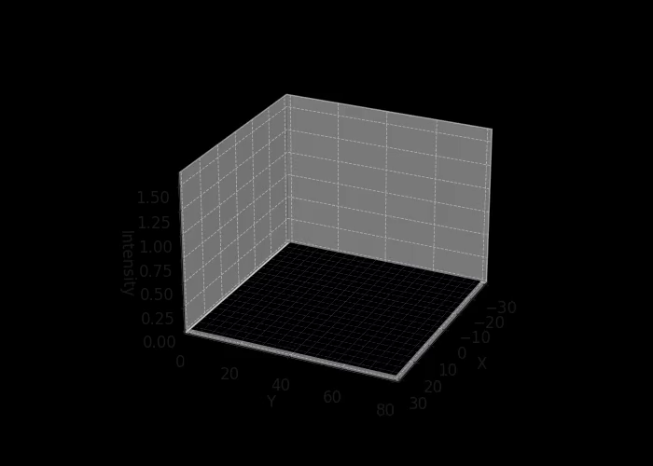

Supplementary Figure S17: Snapshot from imprint_split_with_sensors_tiny.mp4
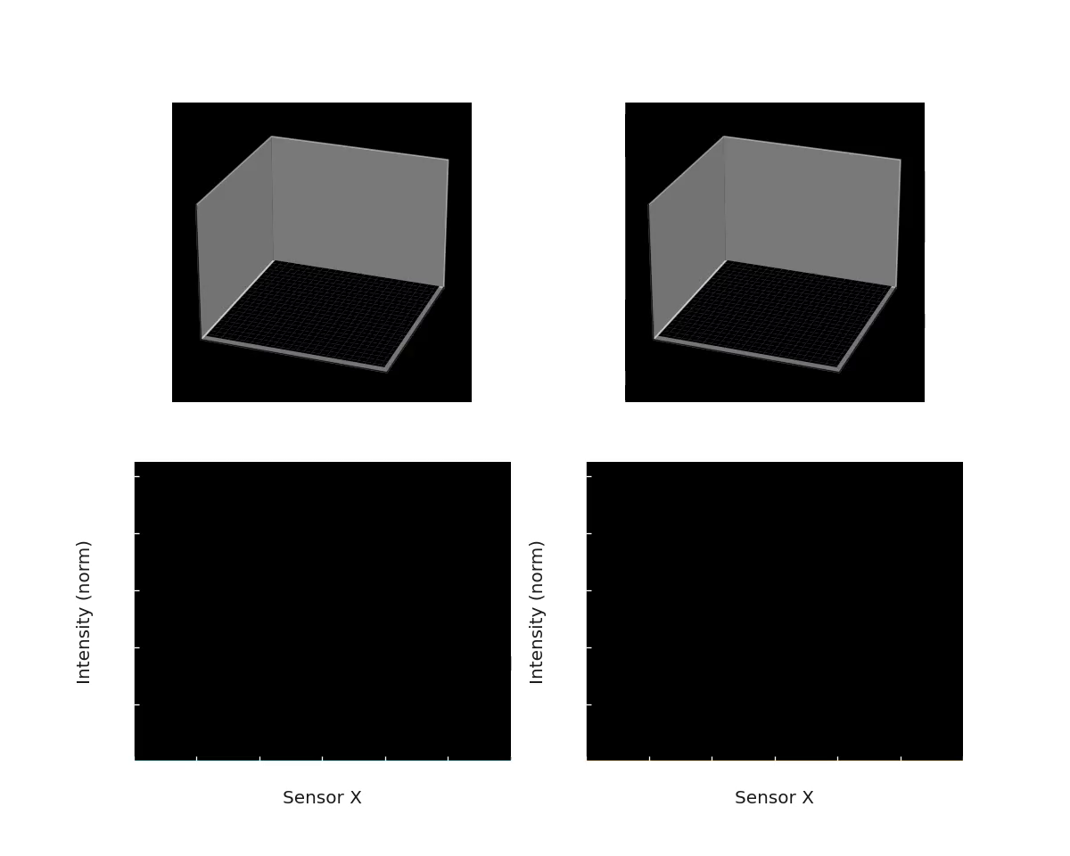

Supplementary Figure S18: Snapshot from imprint_split_coherent_vs_doublebands_tiny.mp4
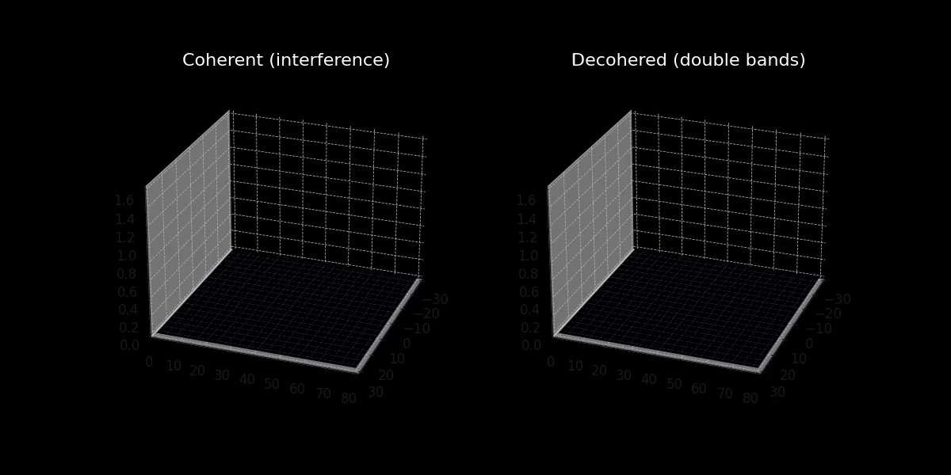

Supplementary Figure S19: Snapshot from imprint_field_chsh.mp4
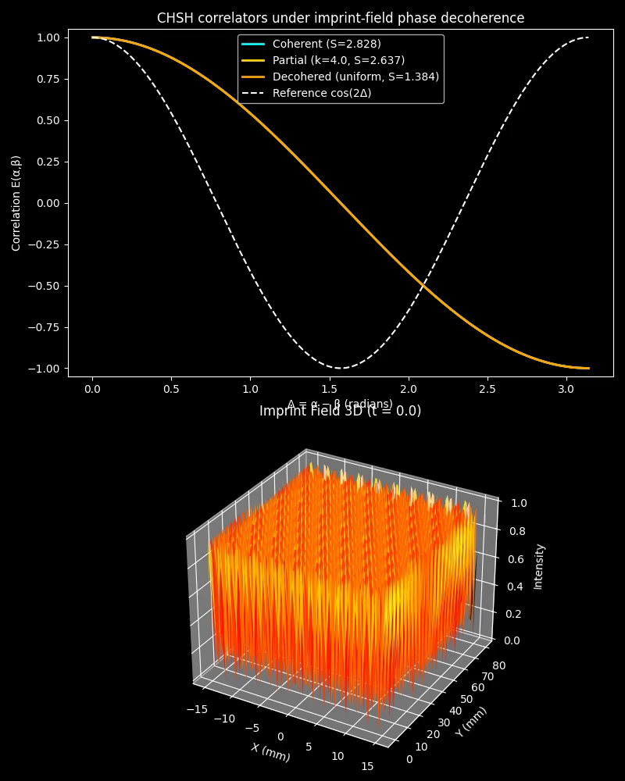

Supplementary Figure S20: imprint_split_with_sensors_snapshot.png
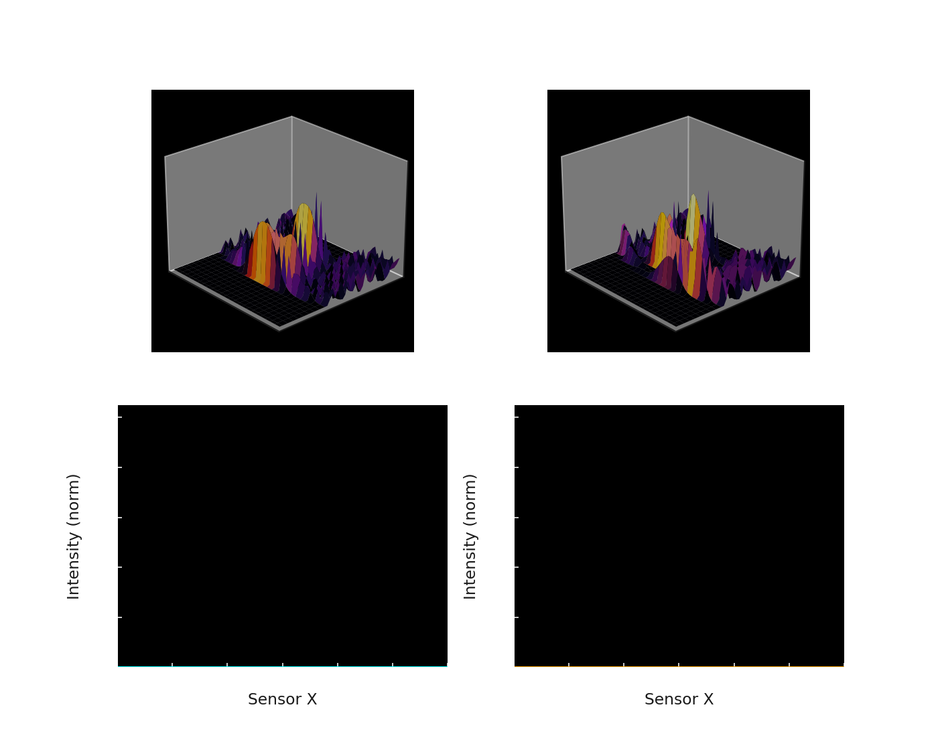

Supplementary Figure S21: imprint_camera_view (1).gif (first frame)


Appendix A: Full Mathematical Derivations
Full derivations of the imprint field wave equation, coherence metrics, decoherence operator, and CHSH derivation go here. (Populate with formal derivations.)

